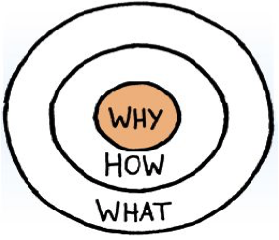

WHAT IS YOUR UNIQUE CONTRIBUTION TO THE WORLD?

HOW DO YOU GO ABOUT MAKING AN IMPACT?

WHY IS THIS PERSONALLY IMPORTANT TO YOU? WHAT ARE YOU DEEPLY PASSIONATE ABOUT?

